Carbon’s Role in Polymers and Life –Ch. 8.3 and 8.4
Ch 8.3 Polymers
- Polymers are __________ complex molecules built from smaller molecules joined together in a __________________ __________________.
- Most polymers contain the element _________________.
- Carbon can form large _____________________ because:
  - 1. it can make ____ covalent ______________
  - 2. carbon can form straight __________, branched chains and _______________.
- Ex of Polymers: ___________________________________________________________________
- Key Question: What element is found in almost all polymers and why??
    - Answer: _________________________________________________
Natural polymers
- ______________, starch, silk, ___________, and cotton are examples of ________________
polymers.
- You ______ polymers daily in the form of carbohydrates, __________, and _________.
- Other natural polymers are used in __________ for their ____________ like silk and cotton.
Synthetic polymers
- Synthetic means ‘_______ ___________’
- The most commonly used ____________ polymer is all forms of __________.
- Plastic and many synthetic polymers are made from _______ or coal, both ___________ ___________.
- Ex of synthetic polymers: ___________, nylon, rayon, ____________, styrofoam, _____________.
- Key Question: List 5 examples of polymers you see in our classroom, natural or synthetic:
  - Answer: _____________________________________________________________________
Ch 8.4 Life with Carbon
4 classes of organic compounds
- We eat _____________ compounds daily for __________, growth, and to _____________ our bodies.
- The 3 main groups of organic compounds required by living thing that we eat are:
  - _________________________
  - _________________________
  - _________________________
- Our _______ make the 4th class of organic compounds: _________ _______. (DNA and RNA)
Carbohydrates
- Carbohydrate – an ______ -rich organic compound made of the elements __________, hydrogen and ____________
- Simple carbohydrate – the simplest carbs are ________ (glucose is in your body – C₆H₁₂O₆)
ex: ________, sugar, fruit juice, yogurt, and ___________ all contain simple carbs.
- Complex carbohydrate – a ___________ made of smaller molecules that are simple ________ bonded to one another
  - Ex: __________________________________________________________________
Carbohydrates are polymers made of repeating chains of sugar molecules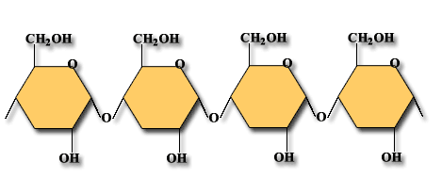

Proteins
Proteins are polymers made of repeating chains of amino acids

- Proteins – formed from smaller molecules called __________ _________
  - Your _________, hair, _______, and fingernails are all made of ____________________.
- Amino acid – a ______________ that is a building block of ______________.
- Each amino acid molecule has a ____________ group (–COOH) and an _______________ group (–NH₃)
  - The body uses proteins from food to _________ and ________ body parts and to regulate ________________________________________
- Examples of food with protein: meat, dairy, eggs, spinach, beans, and nuts.

Lipids
- Lipids – ___________-rich compounds made of _________, oxygen and _____________
  - Lipids include _______, oils, waxes and __________________
- Gram for gram, lipids release __________as much energy in your body as do __________________
- Ex of food sources with lipids: oil, ___________, dairy products, ______, nuts, and ______________
- ________________ fats = have no double bonds, harder to break down.
- ________________ fats = have double bonds, easier to break down.
- Fatty acids – organic compound that is a _______________ of a fat or oil
- Cholesterol – a waxy lipid in animal cells used to build ______ _______________and acts as chemical messengers.
Nucleic Acids
- Nucleic acids – very large ____________ molecules made up of carbon, oxygen, hydrogen, nitrogen and phosphorus
  - Two types – ______ and _________
Fats are polymers made of fatty acids and glycerol.
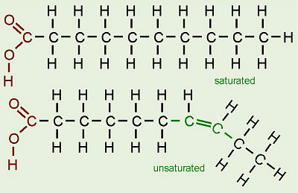
- Elements that make up all living things…
  - C – _____________________
  - H – _____________________
  - N – _____________________
  - O – _____________________
  - P – _____________________
  - S – _____________________

Carbohydrates – polymer made of sugar molecules. Below is a starch molecule.

Proteins – polymer made of amino acids

