Motion and Calculating Speed Notes
Motion is when an object ____________place or _____________. To properly describe motion, you need to use the following:
- Start and end _______________?
- _____________ relative to what?
- How _________ did it go?
- In what _______________did it go?
What Is Speed?
- Speed is the ____________ an object travels in a certain amount of ______.
- To calculate speed, you use the following formula:
Speed (s) = _______________
Suppose you ran 2 km in 10 min. What is your speed?
S= D = __________ = km/min.
T
What is the speed of a car traveling 144 km in 2 hours?
________________ km/h

Show work: Speed = Distance
Time

The Pyramid method:

- To Find Distance: Formula:
- How far can a snail travel at 30 cm/hr in 6 hours?

- To Find Time: Formula:

- How long will it take the snail to cross the road that is 4 meters (400 cm) across traveling at a speed of 30 cm/hr?
- ____________ speed is when you are traveling at the ______________ of speed, such as 55 mph constantly on a highway.
- Average speed is taking the _________ _________ ___________, and dividing by the ___________ ____________ it takes. Used for calculations that involve _________________ speed.
- Instantaneous speed is the speed at any ______ _________ ________ in time.
- Velocity – is the speed of an object in a __________ _____________. Ex:

Motion Graphs
Slope – _______________ of a line on a graph
Slope = rise

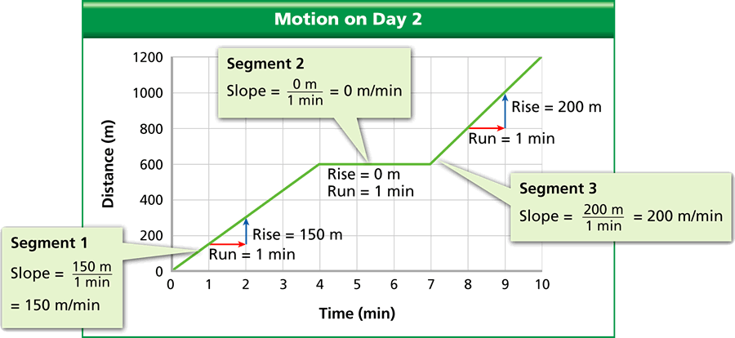
- The slope of a _____________ vs ___________ graph represents _________ – the rate that distance changes in relation to time

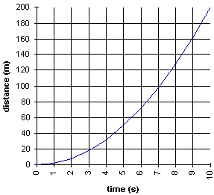
- Plot distance against time to create a line graph of motion
- Distance is on the _________________ axis (y)
- Time is on the _________________ axis (x)

