Chapter 4 Notes – The Periodic Table
Matter
- All the ‘stuff’ of the universe is composed of _______________. Ex: air, you, your table, a pencil, a star, etc…
- Matter – anything that has ________, and takes up __________.
- The _______________ particle of matter is an _________.
- The ___________ of the atom determines the ______ of _________.
  - Ex: Aluminum is different than _______ because it’s _________ are different.
Atoms
- An atom consists of 3 main parts: __________, _____________, and __________.
- Protons and neutrons are in the ___________(the center of the atom), while electrons ______________ the nucleus. (like ___________ around our sun)
- Protons have a ________________________ (+), neutrons are ____________(0), while electrons have a _______________________ (-).
Structure of an Atom
Subatomic Particle | Charge | Symbol | Mass | Location
Proton
Neutron
Electron
The Periodic Table
- All _____________ in the universe is made up of ________________.
- The periodic table __________________ the elements by __________ ______________ (the # of _____________ in the nucleus).
- Atomic Number = # of protons in the nucleus (this is what ____________ the element)
- Atomic Mass = sum of __________ + ______________ in the nucleus
- In an atom, the number of ____________ (+) are equal to the number of _________(-) , so the charges balance out and the atom has a neutral overall charge
Reading the Element Square
- To find the number of protons: it’s the same as the ______________________
- To find the number of electrons: it’s the same as the ________________________
- To find the number of neutrons:

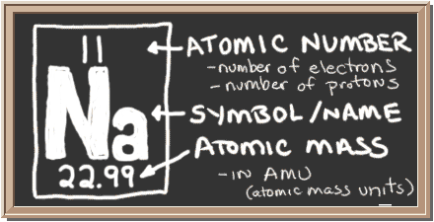
Families
- Families or groups are in __________ columns (18) and elements in a ___________ have similar ____________ or properties.
  - Elements in a family can make the same number of ____________ and so have similar ____________________ properties
Periods
- Periods are the ___________________ rows. Elements in a period DO NOT have similar ___________________. Numbered 1-7.
- Elements in a period have the same # of ______________ shells.
Organizing the Elements
- Elements are also classified as ____________, nonmetals or ______________according to their properties
- The _____ ___________ line on the table separates these categories
- To the left:___________ To the right:________________
Touching the zig zag line= __________________
Metals
- Metals have similar physical properties. They are:
  - _______________
  - _________________ – can bend or pound into shapes
  - _______________ – can form into wires
  - Good _________________ of heat and electricity
  - High ___________________ points
  - Hard
- Chemical properties can vary. Some can corrode, and some are very reactive.
Non-Metals
- Non-metals have the ______________ properties of metals. They are:
  - _________________
  - _________________
  - Non-conductive (_______________)
  - Low ______________ points
  - Mostly ___________ at room temperature
- Chemical properties:
  - All non-metals can form compounds except the __________ ________
  - Noble gases (inert gases) – the _________ family on the periodic table that does not _________ with anything. They are the snobs of the table.
  - Ex: ____________________________
Properties of Semi-metals (Also Called Metalloids)
- The semi-metals can have _________________ of both metals and nonmetals.
- Their most useful property is that they are ______ ______________.
- Semi-conductor – the varying ability to ________ ______________. Used in every __________ __________ in the world.
- Example: silicon

