Chapter 8 Review Sheet

Carbon Atomic Structure
Number of Protons _____  Number of Electrons _____  Number of Neutrons _____ | # of Energy Shells _____  # of Valence e- _____  # of Bonding Sites _____  # of e- to feel complete _____ | Draw Bohr’s Model

Pure Forms of Carbon
Form | Describe Molecular Arrangement (shape) | How is it used?

Carbon Compounds
Compounds that contain carbon are also called ______________________.

Hydrocarbons only contain these 2 elements ________________ and _______________.

Hydrocarbons are used as fuel because they are _________________.

Draw
Methane CH₄ | Ethane C₂H₆ | Methyl Alcohol CH₃OH

How many bonds can carbon make? ____________________

Label the following hydrocarbon structures (straight, branched, ring)
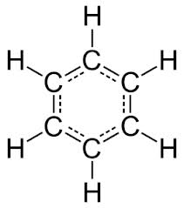 | 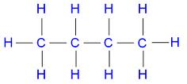 | 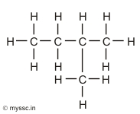

Saturated hydrocarbons only have _________ bonds. Their chemical name ends in _____.

Unsaturated hydrocarbons contain a _________ bond. Their chemical name ends in _____.
Polymers
Definition:___________________________________________________________

Examples of naturally occurring polymers: ______________, ____________, __________.

Examples of synthetic polymers: _______________, _____________, _____________.

Proteins are _____________ made of monomers called __________________________.

DNA is a _______________ made of monomers called ___________________________.

Draw 2 examples of each
Monomer Model | Polymer Model

Organic Compounds in Living Things

Organic compounds all contain _______________________.
4 Classes of Organic Compounds | Monomers these compounds are composed of: | Characteristics

The most abundant elements in the human body are _________, __________, _________.

The simplest carbohydrates are made of __________________.

